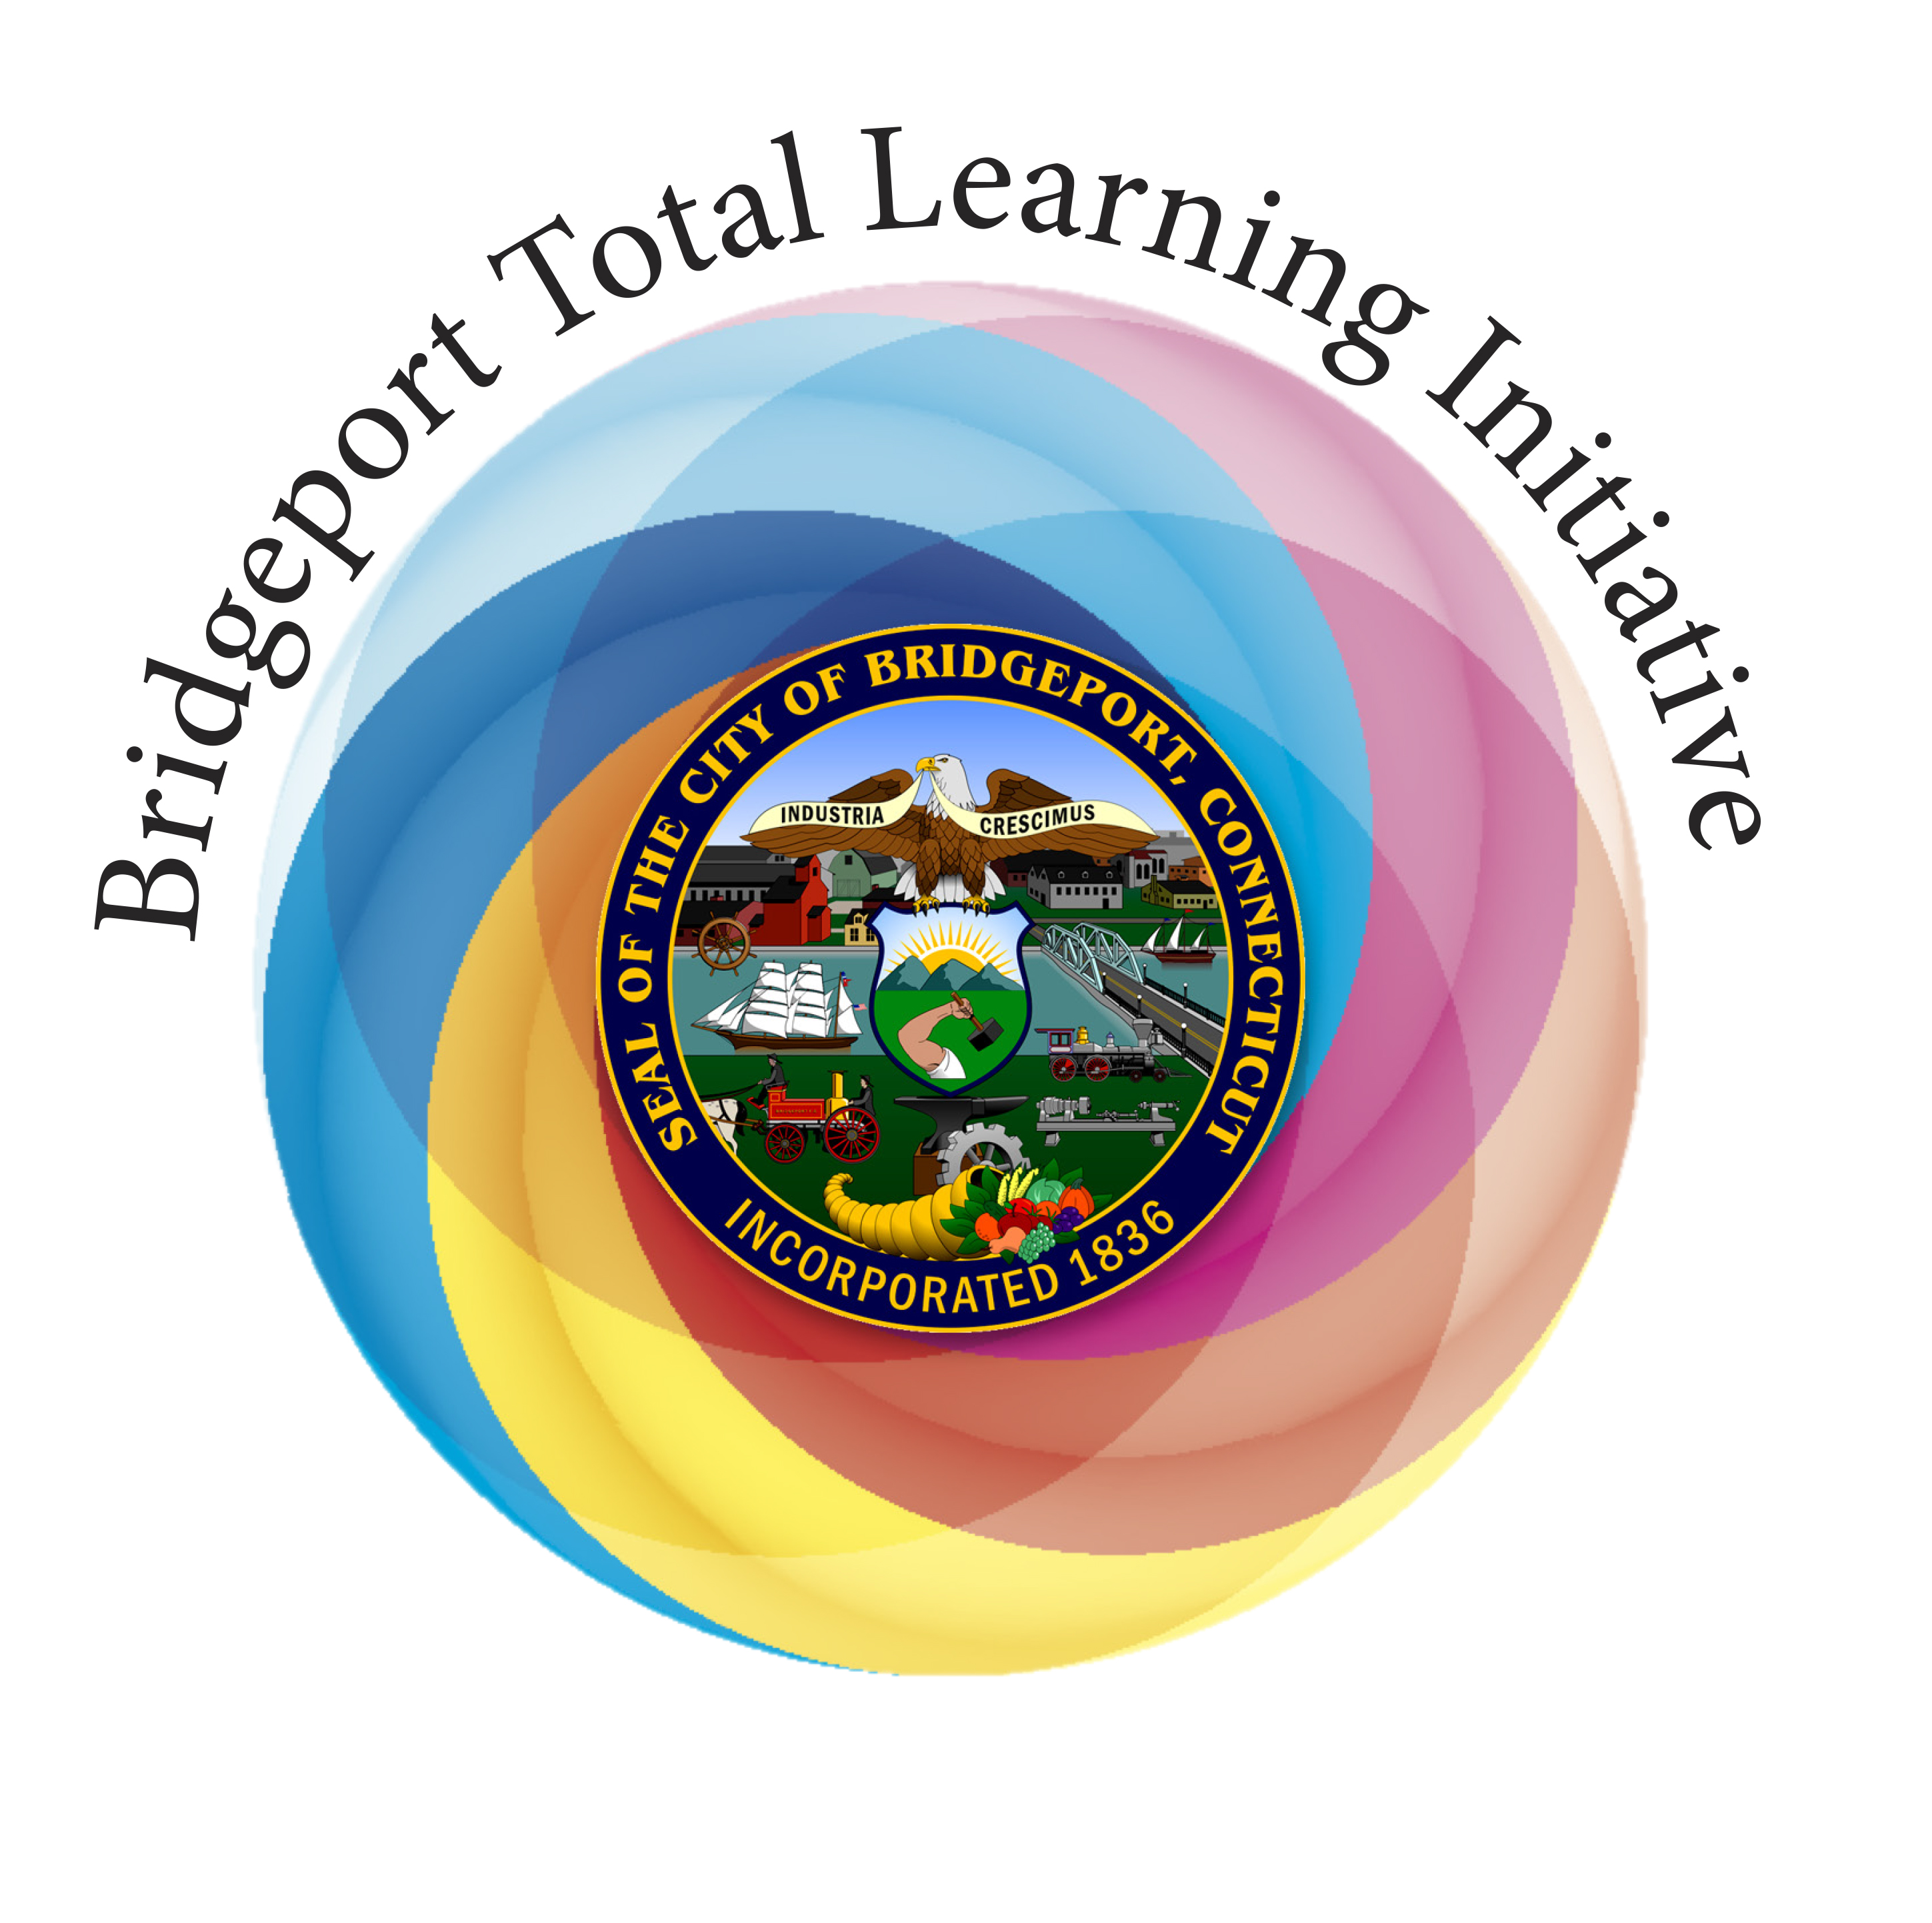
“Expect Great Things”: From Slogan to Reality in Bridgeport, CT
By Allison Logan, Director of Educational Initiatives, ABCD Inc.
This article appeared in the December 2014 CABE (Connecticut Association of Boards of Education) Journal, Volume 18, No. 11.

“There is something great happening here in Bridgeport!” says Frances Rabinowitz, Interim Superintendent of the Bridgeport Public Schools, as she leads the way in bringing a unique, joyful approach for public school reform to her school district. The Bridgeport Total Learning Initiative (BTLI) is a model birth to age nine approach that has been shown to be effective in increasing teacher quality; engaging parents, family, and community; improving classroom/school climate; and ultimately reducing the achievement gap.
“I have seen first-hand the joy of parents and infants/toddlers, sharing in music and movement classes that develop essential pre-reading skills such as sequencing, attentive listening, and patterning. I am dedicated to expanding to more schools, to engage an increasing number of families and their children in Bridgeport. The parental participation in the program has been truly extraordinary.”
~ Superintendent Rabinowitz
The Issue~ The Achievement Gap
The plight of the Bridgeport Public Schools is common knowledge in the state and beyond. The Bridgeport Child Advocacy Coalition estimates that 25% (or 2,540 children) of all Bridgeport children under the age of five are living in poverty. Students in Bridgeport schools emerge significantly behind their peers from the surrounding more affluent communities on all achievement measures as a result of these economic and social conditions.
The Plan - Development of a Model Approach
The BTLI is not a new “commodity” in the Bridgeport Public Schools. Started in 2006, the Initiative was developed by Action for Bridgeport Community Development (ABCD), in collaboration with the State of Connecticut, Bridgeport Board of Education, arts education IDEAS LLC, Child First, The Michael Cohen Group, and Music Together™. The goal of the Initiative was to develop and implement a comprehensive and “whole child” approach to addressing the achievement gap.
Expanding the Head Start model, the Total Learning approach is grounded in the belief that in order to effectively learn, children must be supported socially, academically, and through addressing the needs of the family as a whole, starting at birth and extending up through the fourth grade.
The Bridgeport Total Learning Initiative - What is it?
Intentionally designed and meticulously studied, the BTLI’s multi-faceted approach is comprised of multiple components, both educational and social.
- An Enhanced Learning Environment through multi-sensory teaching and learning, powerful professional development PK-4, smaller staff ratio, and extended school day and year.
- Family Support through family advocates, workshops, parent events, and creation of family service plans.
- Parent Infant/Toddler Engagement through Music Together classes that bring parents and their youngest children together, engaging in music/movement activities that foster brain development and early learning skills.
- Independent Research through gold standard measures, looking at student/child achievement both social and academic, teacher efficacy and interactions, parent engagement, and overall effectiveness of the approach.
Impact of the Approach - Does it work? The Bridgeport Total Learning Initiative works!
The most recent evaluation demonstrated that teachers made statistically significant gains in classroom instruction and that students in TLI classrooms improved in their CMT scores at higher rates than at control schools. Evaluation results have also shown that when implemented with fidelity, children in TLI classrooms demonstrate significantly higher gains in early reading, literacy, and math skills than students in control classrooms.
“The BTLI provides a best practice model for sustaining public-private partnerships to combat the overwhelming consequences of poverty.”
In addition to the evaluative results, there has been overwhelming teacher, administration, parental, and student support of the initiative. Teachers have noted a renewed joy in teaching, with their students demonstrating a marked increase in engagement and achievement. Parents have joyfully engaged in the school community with extraordinary participation, feeling supported and a partner in their children’s learning.

A True Collaborative Partner - Where We Are Now?
In working partnership with district and state goals, this year, with complete support of Superintendent Rabinowitz, Bridgeport maintains a model Total Learning PK-4 School and has expanded the Music Together portion of the initiative to five family resource centers and three additional PK classrooms.
The BTLI has received national attention through the introduction of H.R.3983- The Total Learning Act, a congressional bill to support the Bridgeport model and make it available for replication throughout the city, as well as other school systems throughout Connecticut and the nation.
For further information: www.abcd.org. To find out more or come see the BTLI in action, please contact Allison Logan at alogan@abcd.org /(203) 366-8241 Ext. 237.

State of the Child in Bridgeport, 2012 Report – Bridgeport Child Advocacy Coalition
The Total Learning Initiative: Program Overview, Implementation, and Evaluation 2006-present. Michael Cohen Group, 2014.

